**Wire shark- TCP and UDP**

* **TCP WIRE SHARK**

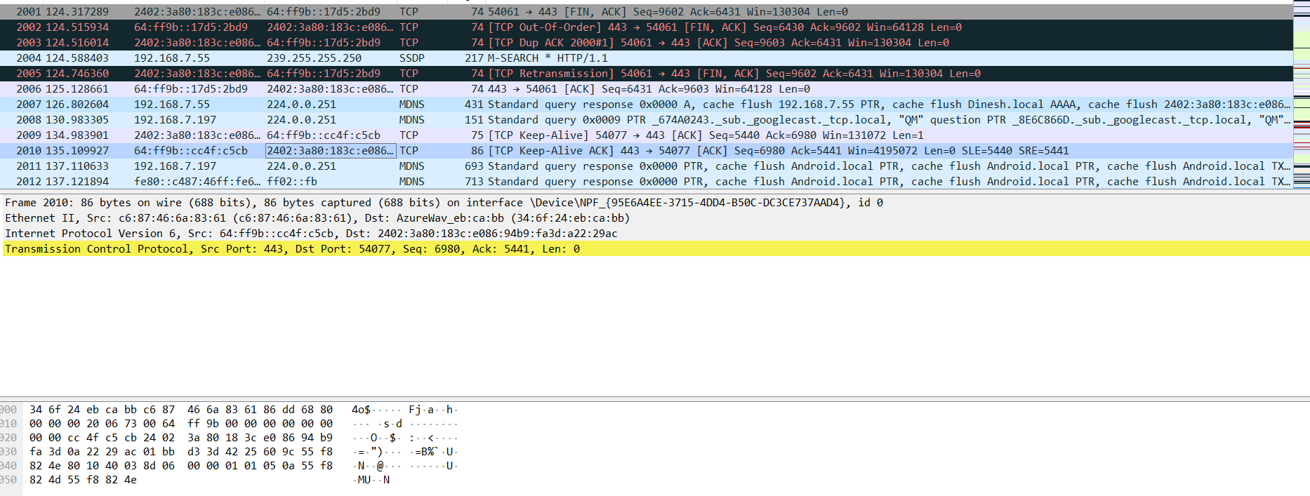

* **UDP WIRE SHARK**

